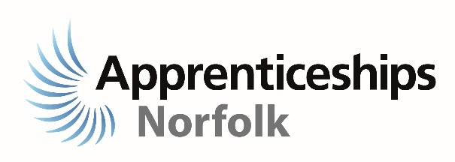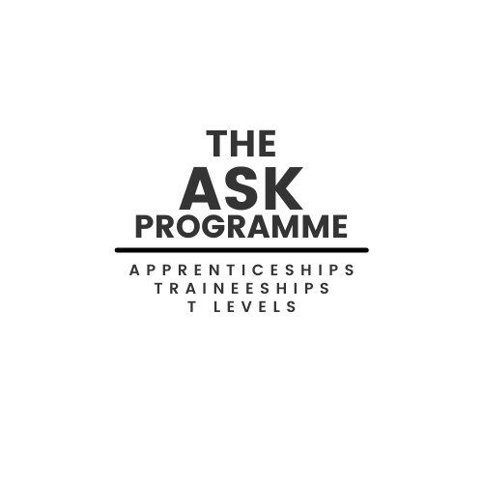



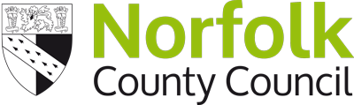

**Pathways into Work**

**Email:** [**ptw@norfolk.gov.uk**](mailto:ptw@norfolk.gov.uk)

**Who we are and how we can support you**

We are the Pathways to Work Team, supporting young people aged 13-19 (25 with EHCP) across Norfolk. We can provide you with information, advice and guidance in exploring work-based post 16 pathways such as Apprenticeships, Traineeships and T-Levels.

You are invited to a FREE online session to find out more about work-based options and employment opportunities in Norfolk for young people.

Date: Thursday 10 February

Time: 7pm – 8pm

No booking or appointment needed to join the session click on the link below:

**J**

[Click here to join the meeting](https://teams.microsoft.com/l/meetup-join/19%3ameeting_Y2IxMTE2MDQtNWM4Mi00ZmU5LTg4NjItMDc4NjAyZGQxNmNl%40thread.v2/0?context=%7b%22Tid%22%3a%221419177e-57e0-4f0f-aff0-fd61b549d10e%22%2c%22Oid%22%3a%223b36cc9b-20bf-41e7-9904-e3aa8777f248%22%7d)